Homework 4

Henrik Lucander, 724140

# Problem 1)

## a)

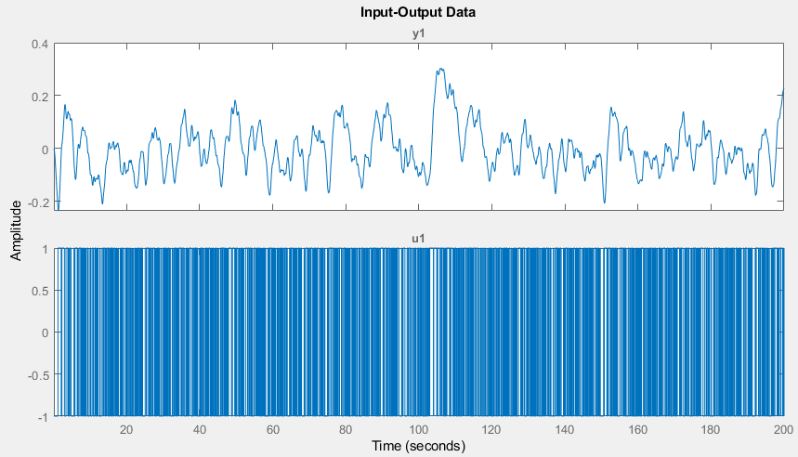

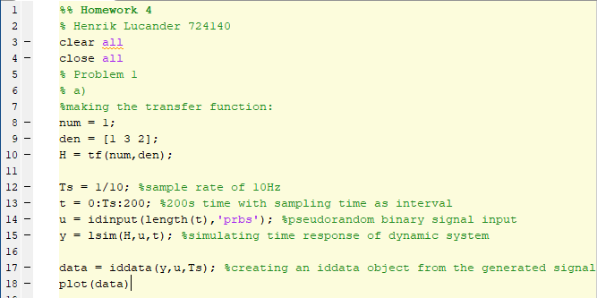

## b)

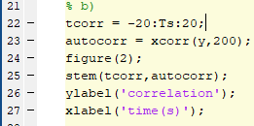

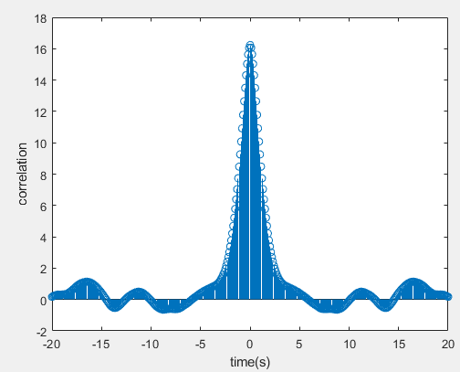

## c)

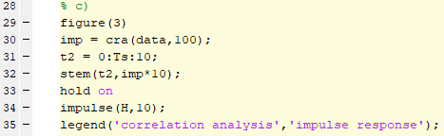

## d)

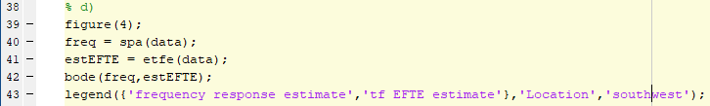

# Problem 2)

## a)

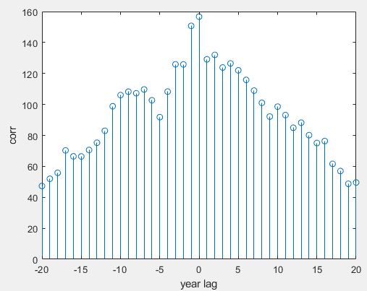We can analyze the relationship between oil consumption and economic growth by cross correlation.

The variables are correlated, but not very highly. We can see from the plot that the highest correlation is at 0. Therefore, we can say that there is no delay(lag) in the correlation (from year to year).

## b)

In the plot we can see the estimations for the polynomial model with 2nd order and 3rd order. We can see that the second order fits better.

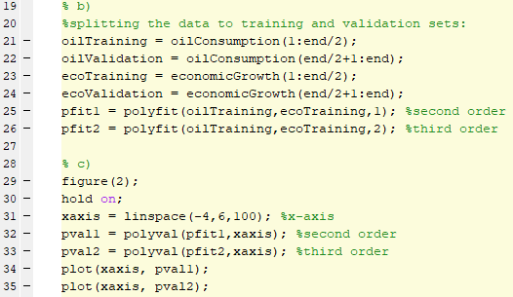The m-code used for estimating the polynomial model:

## c)

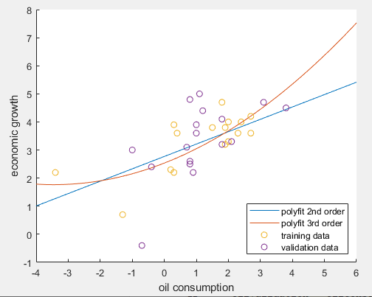The estimation function in part “b” plotted as the blue line.

The prediction for the economic growth in year 2015 if the oil consumption percentage change was -0.5% is: **2.5505%**

